Decision Support System Based on Multi-Criteria Decision-Making (MCDM) for Optimizing Digital Transformation Priorities
Irakli Basheleishvili, Elza Bitsadze
Abstract For modern organizations, digital transformation is critically important. However, correctly setting priorities for its initiatives is often a significant challenge due to numerous criteria and stakeholders involved. To address this, we present a Multi-Criteria Decision-Making (MCDM)-based decision support system. This system aims to identify and select the optimal priorities for digital transformation projects.
The proposed system utilizes MCDM methods for objective evaluation and comparison of projects. This approach allows organizations to effectively allocate resources by considering criteria such as: financial efficiency, operational improvement, customer experience, risk management, and strategic alignment. The system integrates modules that facilitate data collection, criteria evaluation, alternative ranking, and sensitivity analysis, helping users assess decision stability under changing conditions.
By using this system, organizations can:
- Improve the decision-making process: The system provides a structured and transparent approach for setting priorities, which reduces subjectivity.
- Reduce risks: MCDM methods enable the identification and minimization of potential risks before project initiation.
- Maximize value: Optimal resource allocation allows for maximizing benefits from investments, contributing to organizational growth.
- Strengthen collaboration: The system fosters the involvement of stakeholders in the decision-making process, ensuring consensus-based decisions.
This decision support system is a powerful tool for organizations striving to successfully implement digital transformation in a complex and dynamic environment, enabling them to make informed and data-driven decisions for long-term success.

Keywords Digital Transformation · MCDM (Multi-Criteria Decision-Making) · Prioritization · Decision Support

Irakli Basheleishvili, Elza Bitsadze
Akaki Tsereteli State University, Kutaisi,Georgia.
e-mail:irakli.basheleishvili@atsu.edu.ge, elza.bitsadze@atsu.edu.ge
1 Introduction
The contemporary competitive business landscape is characterized by significant complexity and volatility, where the long-term success and sustainability of organizations depend on their ability to adapt to rapid technological progress. In this context, digital transformation is no longer a mere trend but a strategic necessity that impacts every aspect of an organization—from operational efficiency to customer relations. However, despite most organizations recognizing the importance of this process, the effective management and proper prioritization of digital transformation initiatives often present a serious challenge. The main reason for this challenge lies in the fact that digital projects must be evaluated against multiple, often conflicting, criteria.
Decision-making in this field is complex because it requires considering not only financial benefits but also evaluating qualitative factors such as improved customer experience, enhanced brand reputation, streamlined internal processes, and minimized risks. Traditional decision-making models, which primarily focus on a single criterion, are unable to fully analyze this multidimensional problem. As a result, managers often rely on subjective assessments, which can be biased and lead to the suboptimal allocation of resources. Such decisions can result in projects that are ineffective or strategically misaligned, ultimately hindering the organization's growth and reducing its competitiveness.
Therefore, the objective of our research is to develop a Decision Support System (DSS) based on a Multi-Criteria Decision-Making (MCDM) methodology. Our approach is aimed at addressing the challenges described above by providing organizations with a tool that ensures:
- Objectivity: Minimizing subjective, individual assessments and integrating all relevant criteria.
- Transparency: Documenting and justifying the decision-making process.
- Optimization: Allocating resources in a way that generates maximum value for the organization.
Our proposed system combines well-known MCDM methods, such as the Analytic Hierarchy Process (AHP) for determining criteria weights and TOPSIS for ranking projects. This combination allows us to create a powerful framework that not only evaluates existing projects but also performs a sensitivity analysis, which helps organizations assess the stability of their decisions under changing business conditions. Ultimately, this paper argues that an MCDM-based DSS is an essential tool for organizations striving for successful digital transformation and long-term competitiveness.

2 Problem Definition and Formulation

Managing digital transformation projects is a multidimensional problem that presents significant challenges for business leaders. The main difficulty lies in the fact that digital initiatives cannot be evaluated by a single criterion alone, such as a financial one. Traditional investment analysis methods, like Net Present Value (NPV) or Internal Rate of Return (IRR), often fail to account for the non-financial benefits that digital projects create. For example, automating operational processes may not be immediately profitable in the short term, but over the long run, it can significantly reduce costs and increase productivity.
Furthermore, the decision-making process often involves representatives from various departments (e.g., finance, IT, marketing, operations), all of whom have different goals and priorities. For instance, the IT department may prioritize technological compatibility and security, while the marketing team may focus on customer satisfaction and brand awareness. These differing interests frequently lead to conflicts, which can either delay the decision or result in the selection of projects that do not serve the organization’s overall strategic objectives.
Consequently, the problem can be formulated as follows:
Problem: How can an organization develop a process for prioritizing digital transformation initiatives that is objective, transparent, and data-driven, in order to overcome the challenges posed by multiple conflicting criteria and the subjective assessments of various stakeholders?
To solve this problem, it is essential to create a systematic framework that:
- Integrates both quantitative (financial indicators, project duration) and qualitative (risks, strategic alignment) criteria.
- Ensures consistency and transparency in the decision-making process.
- Reduces the subjectivity of stakeholders, allowing for the optimal allocation of resources.
Our research aims to address this very problem using the MCDM (Multi-Criteria Decision-Making) methodology.

3 Literature Review

The problem of prioritizing digital transformation has been extensively studied in the fields of management science and operational research. Numerous approaches exist; however, the majority fail to fully encompass all aspects of complex decision-making.
Traditional Financial Methods: Initially, the evaluation of digital projects was primarily based on financial indicators. Methods such as Net Present Value (NPV), Return on Investment (ROI), and Internal Rate of Return (IRR) were widely used to assess the economic viability of projects (Brealey et al., 2017). However, as Goodman & Loveman (1999) noted, these methods cannot account for the intangible value created by digital initiatives, such as brand reputation, customer loyalty, or increased employee productivity. Due to these limitations, these approaches have become less relevant for solving complex problems like digital transformation.
Multi-Criteria Decision-Making (MCDM) and Its Advantages: In response to the shortcomings of traditional methods, the benefits of Multi-Criteria Decision-Making (MCDM) methods have become increasingly recognized in academic circles. MCDM provides a structured approach that allows for the simultaneous evaluation of both quantitative and qualitative criteria (Belton & Stewart, 2002). This approach makes the decision-making process more transparent and reduces subjectivity.
An analysis of the existing literature shows that MCDM methods are the most effective tool for evaluating digital transformation projects. However, it is noteworthy that most research focuses on a single specific method and does not consider integrating MCDM into a full-fledged Decision Support System (DSS) that includes data collection, criteria ranking, and sensitivity analysis. Our paper addresses this gap by proposing a comprehensive system that combines best practices and creates a practical, usable model for organizations.

4 Methodology
The methodology used in this research is based on a hybrid approach to Multi-Criteria Decision-Making (MCDM) methods, which creates a systematic framework for evaluating and prioritizing digital transformation projects. The methodological structure involves four sequential stages that ensure an objective and transparent decision-making process, with the goal of minimizing subjective bias.

Stage 1: Problem Decomposition and Hierarchical Modeling
The starting point of the methodology is the hierarchical structuring of the problem. This process involves breaking down a complex decision task into smaller, manageable components, as defined by the principles of the Analytic Hierarchy Process (AHP). The proposed model consists of three primary levels:
- Goal Level: The highest level represents the main objective of the research—to determine the optimal prioritization of digital transformation initiatives.
- Criteria Level: This level presents a set of evaluation criteria identified through consultation with stakeholders. These criteria include both quantitative (e.g., project cost, payback period) and qualitative (e.g., strategic alignment, risks) factors.
- Alternatives Level: The lowest level contains the potential digital projects to be evaluated.

Stage 2: Determining Criteria Weights Using the AHP Method
This stage uses the AHP methodology to calculate the relative importance of the criteria. Pairwise comparisons are conducted between the criteria using Saaty’s 9-point scale. These assessments are reflected in a comparison matrix, from which the criteria weights (priority vector) are calculated according to the hierarchy principles. This stage also involves calculating the Consistency Index (CI) and the Consistency Ratio (CR), which assess the consistency of the judgments.

Stage 3: Multi-Expert Evaluation and Ranking of Alternatives with the TOPSIS Method
Once the criteria weights are approved, the TOPSIS (Technique for Order Preference by Similarity to an Ideal Solution) method is used for the final ranking of alternatives. TOPSIS is a classic multi-criteria decision-making technique that seeks the optimal solution by using Euclidean distance. At this stage of the process, a group of multiple experts evaluates the alternatives based on the criteria. Each expert assesses all alternatives against each criterion. Their individual assessments are aggregated using the geometric mean, which ensures consensus-based and more objective results. The resulting weighted normalized matrix is then used for the following TOPSIS steps:
- Creation of the Normalized Decision Matrix: The initial data is normalized to neutralize differences between the units of various criteria.
- Creation of the Weighted Normalized Decision Matrix: The normalized matrix is multiplied by the criteria weights calculated by AHP.
- Identification of Ideal and Anti-Ideal Solutions: The best and worst values for each criterion are identified.
- Calculation of Distances: The Euclidean distance of each alternative from the ideal and anti-ideal solutions is calculated.
- Calculation of the Closeness Coefficient: The closeness coefficient (CCi​) is calculated for the final ranking. The alternatives are ranked in descending order of this coefficient.

Stage 4: Sensitivity Analysis
The final stage of the methodology involves a sensitivity analysis, a critical component for assessing the robustness of the decision. The analysis is conducted by varying the criteria weights. The results of these simulations show how the ranking of alternatives changes when priorities are shifted. This stage ensures the validation of the final decision and helps management better assess potential risks.

5 System Prototype and Simulation Study
Within the scope of this research, a web-based Decision Support System (DSS) prototype was created. It's built using modern web technologies, ensuring an intuitive interface and easy navigation through the decision-making stages.
The system prototype is built using a modern and efficient technology stack to ensure performance and scalability.
- Frontend: The user interface is developed with React, a popular JavaScript library known for building dynamic and responsive single-page applications.
- Backend: The server-side logic and API are implemented using PHP, which provides a robust and flexible environment for handling data processing and managing the application's core functionality.

5.1 Prototype Modules
The prototype consists of four main modules that sequentially perform the decision-making task:
- Problem Definition Module: This is the initial stage of the system where the user structures the problem. It involves the hierarchical modeling of the decision task, which includes identifying specific digital transformation projects (alternatives) and the relevant criteria needed for their evaluation. This module ensures that all subsequent analysis is focused on a clearly defined goal and evaluation criteria.
- Criteria Evaluation Module (AHP): In this module, the user performs pairwise comparisons to determine the relative importance of each criterion using Saaty's 9-point scale. The application automatically calculates the criteria weights and checks the consistency of the assessments.
- Decision Matrix Module (TOPSIS): In this module, the user fills out the decision matrix, where each project (alternative) is evaluated against each criterion. This stage is crucial as it incorporates the knowledge and experience of experts, which is then processed mathematically.
- Results and Sensitivity Analysis Module: This module displays the final ranking calculated by TOPSIS, where projects are ordered by their final score. Additionally, a sensitivity analysis feature is integrated into this module. The user can interactively change the criteria weights and observe how the project ranking changes. This feature ensures the evaluation of decision robustness and the minimization of risks.

5.2 Simulation Study
A simulation study was conducted to evaluate the system's effectiveness, based on a real-world business scenario where a company is considering implementing three digital transformation projects. The main objective of the simulation is to evaluate and optimally rank these three projects based on a multi-criteria assessment, in order to identify the project that will create the highest strategic value for the organization.
For this task, we have the following alternatives:
- Alternative 1: CRM system implementation
- Alternative 2: Creating an e-commerce platform
- Alternative 3: Automation of internal operations
The evaluation criteria are presented below:
- C1: Return on Investment (ROI)
- C2: Operational Efficiency
- C3: Customer Satisfaction
- C4: Risk Reduction
We will solve this problem using our developed system prototype. The first step is to define and structure the problem. The process begins with problem definition (Figure 1). Next, the user, within the scope of this specific simulation study, defined four main criteria (Return on Investment, Operational Efficiency, Customer Satisfaction, Risk Reduction) and three alternative projects (CRM system implementation, Creating an e-commerce platform, Automation of internal operations). The definition of these elements is shown in Figure 2.
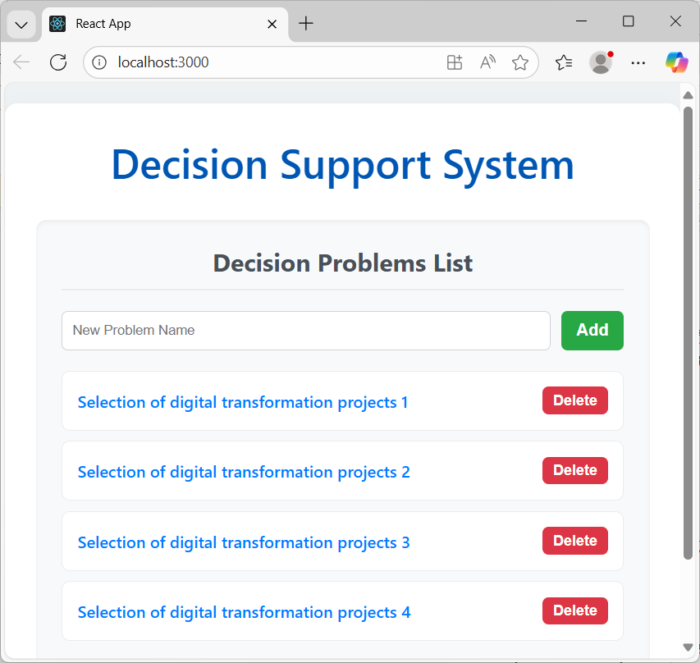
Figure 1. Problem definition
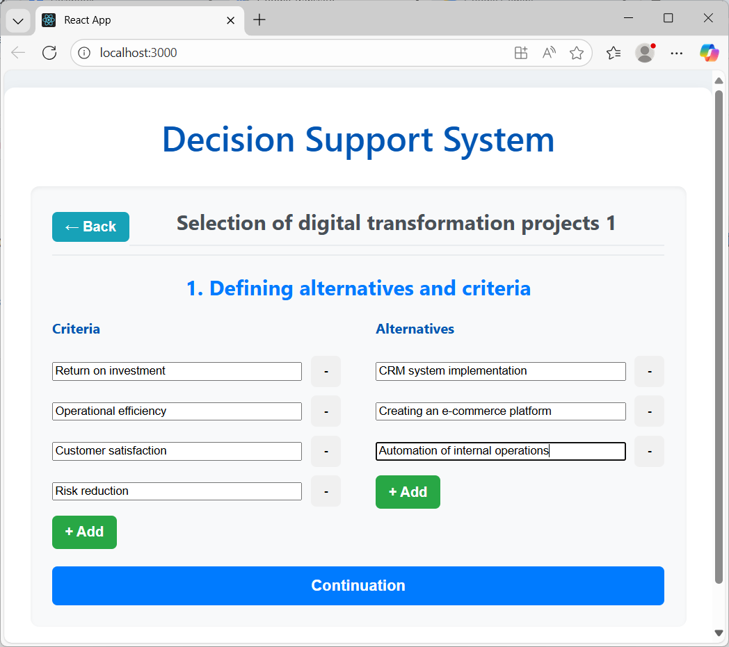
Figure 2. Defining alternatives and evaluation criteria
Following this, the next stage involves calculating the weights for the evaluation criteria (Figure 3). The system moves to the AHP module, where the user performs pairwise comparisons of the criteria using Saaty's 9-point scale. Figure 3 shows the completed matrix from which the system automatically calculates the relative weights of the criteria.
The resulting weights, such as Return on Investment (56.50%), Operational Efficiency (28.43%), and Risk Reduction (4.09%), clearly indicate the organization's priority areas. After the weights are calculated, the system proceeds to the next stage.
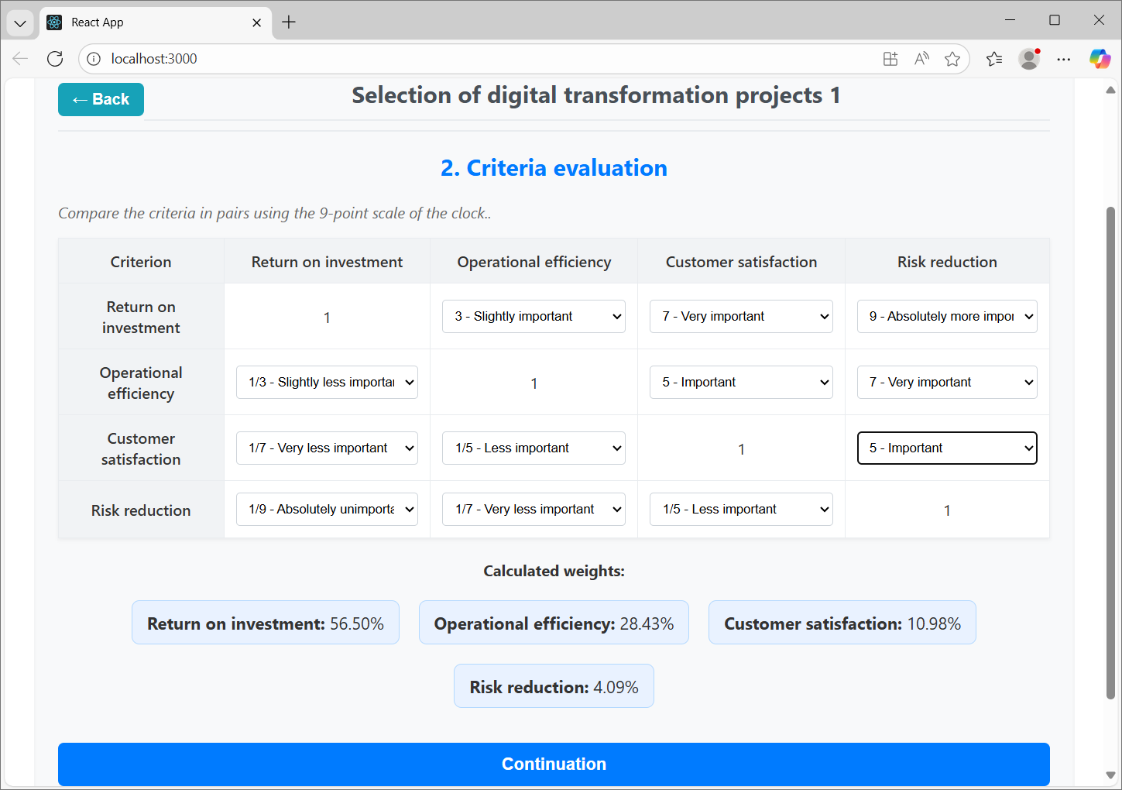
Figure 3. Calculating weights
The next stage involves filling out the decision matrix (Figure 4). The user completes the decision matrix by evaluating the projects on a scale of 1 to 5, which reflects their alignment with each criterion. It's worth noting that the system's design is flexible, allowing the user to choose their own evaluation scale to meet specific needs. These assessments represent a quantitative reflection of expert knowledge, which is essential for the TOPSIS calculations.
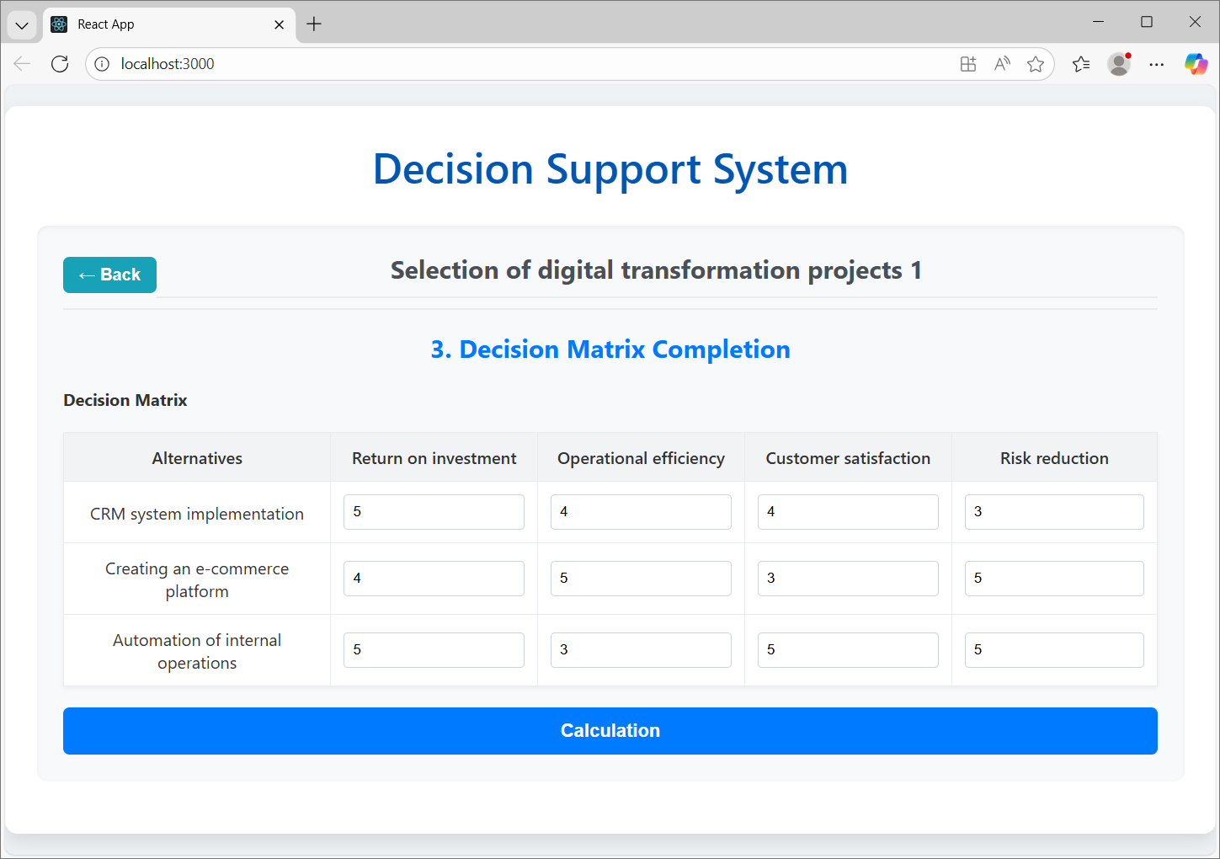
Figure 4. Filling in the decision matrix
At the next stage, the final ranking is determined (Figure 5). After all data is entered, the system automatically performs the TOPSIS calculations and displays the final project ranking. As shown in Figure 5, CRM system implementation receives the highest TOPSIS score (0.648), making it the best alternative. Creating an e-commerce platform is in second place, followed by Automation of internal operations in third. This result is obtained by considering the weight of all criteria.
The practical application of the prototype within the simulation study shows that the developed DSS system successfully structures a complex decision problem, integrates human expert knowledge, and uses a mathematical model to arrive at objective, justified, and transparent decisions.

5 Conclusions
The objective of this research was to solve the problem of evaluating and prioritizing digital transformation projects using a hybrid Multi-Criteria Decision-Making (MCDM) methodology. The paper argues that traditional financial models are ineffective for evaluating these types of projects because they fail to account for intangible values such as strategic alignment and customer loyalty. Our proposed methodology, which combines the Analytic Hierarchy Process (AHP) for determining criteria weights and the TOPSIS method for ranking projects, represents a powerful tool for addressing these challenges.
The developed Decision Support System (DSS) prototype and the simulation study based on it confirmed the practical applicability and effectiveness of our methodology. The analysis showed that the system can objectively and transparently evaluate digital projects, allowing managers to make data-driven and optimal decisions. The main contribution of this paper is the integration of MCDM into a fully functional, practical system that reduces subjectivity and ensures the robustness of the decision-making process through sensitivity analysis.
Although this study provides a solid foundation, there are several directions for future research. First, it is possible to expand the model by integrating Fuzzy Logic, which would further enhance its capabilities for processing vague and incomplete data. Second, it is necessary to conduct extensive empirical studies across various industries to determine the model's universal applicability in real-world environments. Finally, machine learning methods could be embedded into the model, allowing the system to refine its evaluations over time, learn from the outcomes of previous projects, and improve the accuracy of future decisions.

References

